InChI encoding of atropisomers

Atropisomer (AI) – stereoisomer arising from hindered rotation about a single bond, where steric and/or electronic constrains create a barrier to rotation that is high enough to allow for isolation of individual conformers. AIs differ from other hindered conformers having two flat sp2 (or close to flat sp2-like) atoms at both ends of the bond with hindered rotation.
Atropisomers is not so frequent but very distinct class of stereoisomers having some importance in many areas of chemistry, including chemical education.
Atropisomerism is currently not recognized by InChI tools making stereoisomers indistinguishable.
Classical example of AI (represented in classical, but rather superfluous way)
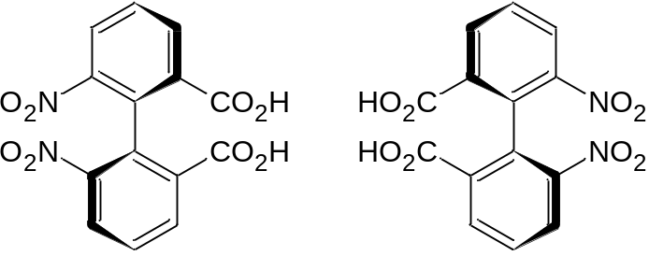
M-isomer P-isomer
Most common AIs include biphenyls and biaryls, but other types are possible also:
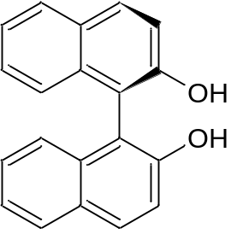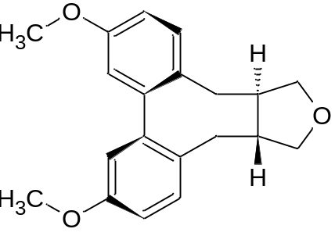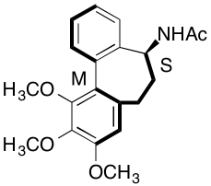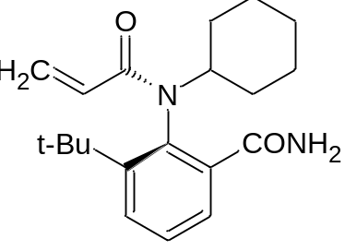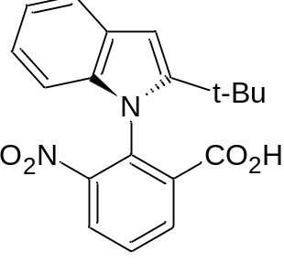

The following procedures are necessary for support of AI encoding by InChI tools:
- Recognition of potentially ‘atropoisomeric unit/bond’;
- Recognition and assignment of the configuration;
- Encoding of AI configurations in InChI.

- Recognition of potentially ‘atropoisomeric unit/bond’
  - Bonding, valence and element restrictions
Most common cases have the following unit with single bond between two sp2 atoms, mostly carbons.
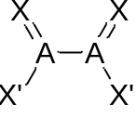 or 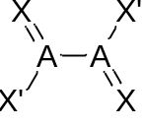 (orientation itself is not important, stereobonds are necessary!)
Atoms A should be four-valent to be sure in flat arrangement of bonds and an absence of implicit hydrogens.
In most cases A = C, but formally nothing prevents it from being Si, N(+) and maybe P(+). Let’s keep this restriction at least for the beginning. Are there any examples with different elements?
Atoms X should be pairwise distinguishable at an each end of AI bond.
Other far less frequent cases may include the following AI units:
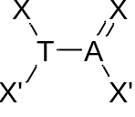 or 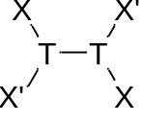
Here atoms T should be three-valent to be sure in the absence of implicit hydrogens.
In most cases for this group T = N. Not sure that other elements should be allowed. P? O(+)???
Atoms X should be again pairwise distinguishable at an each end of AI bond.
For the first version we can consider support of most common AIs with single bonds with four-valent or even carbon atoms only. Up to discussion.
  - Substitution restrictions
A rotation about a single bond has some energetic barrier in any case, but for atropisomers it should be high enough to ensure at least slow interconversion of stereoisomers at reasonable conditions.
As structural criterion for potential stability of AI we can demand the presence of (at least) two additional non-hydrogen substituents at not less than three X atoms:
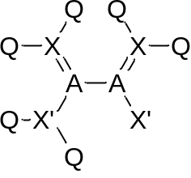 or 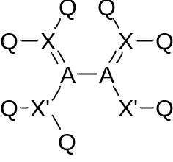 or 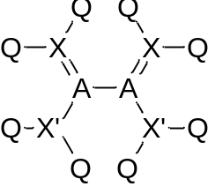
This condition is not enough to ensure stability of atropisomers, but it is a good approximation. Further substitution may be demanded.
A special case that needs only two X atoms at each end to have two more substituents has the following core that is present in AIs with cyclic stereogenic single bond:
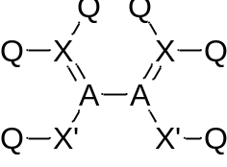 for example in 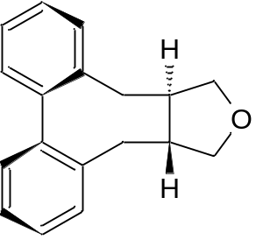or even 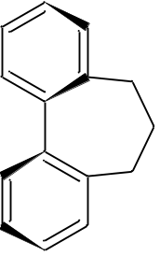
but not in 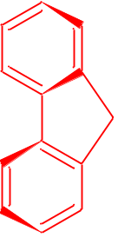or 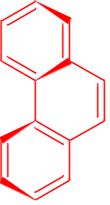or 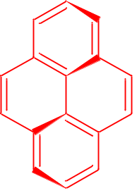
A support of cyclic AI bonds makes the procedures more complex, but still affordable.
  - Designation with stereobonds
To be recognized as stereoisomeric AI bond should be designated with stereo bonds or have the corresponding 3D coordinates.
Only the following arrangements of stereobonds are acceptable for the most common case with double bonds:
with two stereobonds 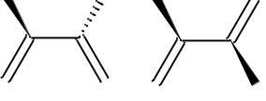 (plus the opposite)
with one stereo bond 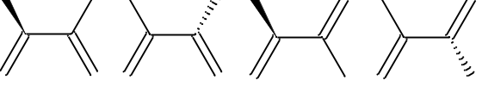 (plus the opposite)
It seems necessary to support AI with single stereobond as soon as such designations are stated as acceptable in IUPAC recommendations:
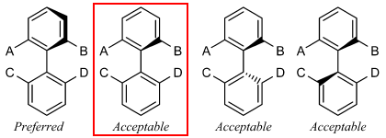
The following arrangements do not specify any configuration
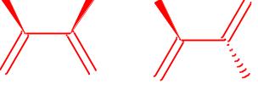 (and the opposite forms 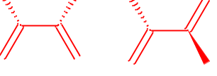)
From the algorithmic point of view it is practically the same as already implemented for allenes having only one stereobond at each end. The following designations are recognized by InChI as stereoisomeric
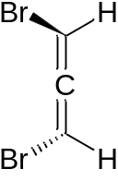 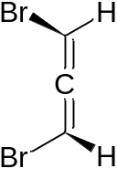 and these are not 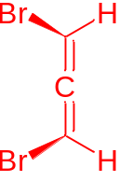 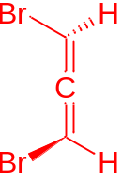
Currently InChI does not recognize stereoisomerism for single stereobond in allenes:
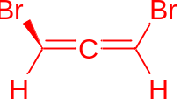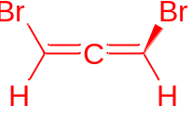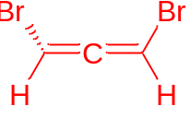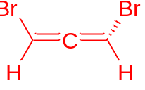
InChI=1S/C3H2Br2/c4-2-1-3-5/h2-3H and LBHCVWCQPDGJBC-UHFFFAOYSA-N
It seems necessary to implement a support of one stereobond in allenes also, at least as soon as such representation is specified as acceptable in IUPAC recommendations:
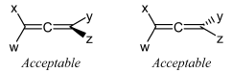
AIs are not so frequent and stereobonds are rarely used in the cases where AIs are not possible, but sometimes additional stereobonds are used like in the following:
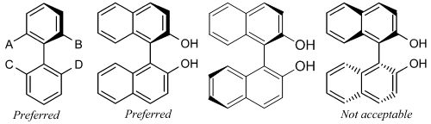
All ‘decorative’ stereobonds should be ignored.
If support of ‘cyclic’ AI bonds is intended there should be the corresponding restrictions about the cycles. For example the red single bond should not be recognized as AI bond in the following cases
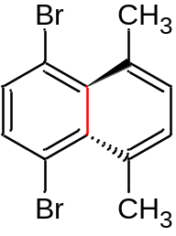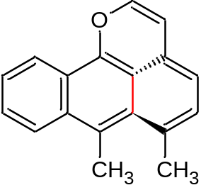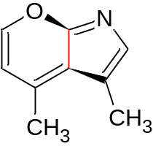
3D structures
In 3D optimized structures biphenyl core is not flat and has torsion angle about 44 degrees along the AI bond. Recognition of distinguishable positions and substitution restrictions mentioned above allows to recognize the cases with rather stable AIs.

- Recognition and assignment of the configuration
It seems the most simple part of this task as soon as InChI already includes the necessary procedures.
Recognition of configuration should work practically in the same way as already implemented for allenes.
For example all the following variants of designation should have the same configuration
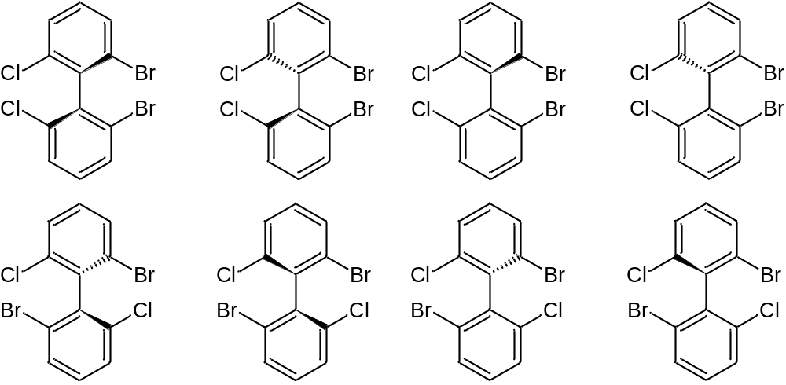
(I am suing Cl and Br as substituents, but they are not large enough to form a stable AI)

- Encoding of AI configurations in InChI
AI unit is enantiomeric, but it is not a center of chirality but a case of chirality axis.
Still it seems logical to indicate configurations of AI units together with the centers of chirality.
Having many aspects of AIs common with allenes we can choose something close. For allenes the central atom is used to specify the chirality in t-layer. For example, the configuration is associated with atom 1 for the following structure:
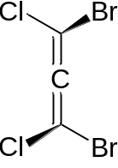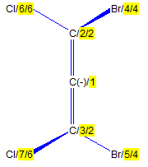
Structure wInChI interface
InChI=1S/C3Br2Cl2/c4-2(6)1-3(5)7/t1-/m0/s1
Now let’s see what we have AI example below:
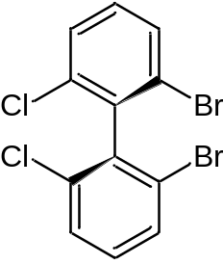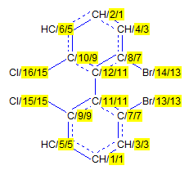
(Obviously wInChI should retain the necessary stereobonds like for allenes)
For AIs we have ‘stereogenic bond’ defined by two atoms (11 and 12) and we can consider two options:
- to cite each atom of the bond with the corresponding descriptor like /t11-,12-/; or
- to cite only one atom with lower number like /t11-/
It is not currently obvious what to choose, but it seems that single cited atom looks better as soon as in such case the InChI is shorter and the number of cited configurations in t-layer corresponds to the number of chirality units.
If we choose single configuration cited for AI instead of the current InChI for the mentioned above structure
InChI=1S/C12H6Br2Cl2/c13-7-3-1-5-9(15)11(7)12-8(14)4-2-6-10(12)16/h1-6H
we will have something like
InChI=1S/C12H6Br2Cl2/c13-7-3-1-5-9(15)11(7)12-8(14)4-2-6-10(12)16/h1-6H/t11-/m0/s1

For the enantiomer it will be
InChI=1S/C12H6Br2Cl2/c13-7-3-1-5-9(15)11(7)12-8(14)4-2-6-10(12)16/h1-6H/t11-/m1/s1

It seems cover all for the beginning of discussion and work with atropoismers. Let’s discuss

